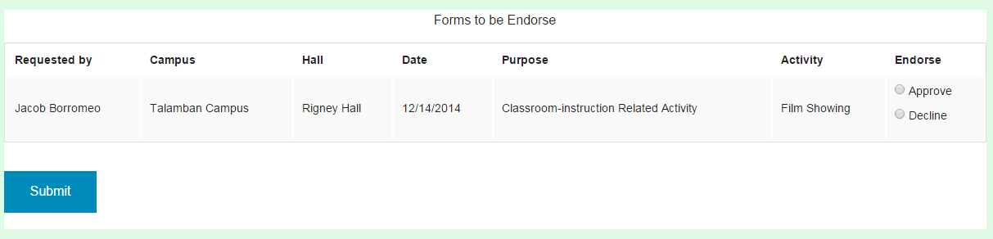

1. Requestor Column
   * Description: This is where the endorser views the requestor of the reservation.
   * Action: Endorser views the requestor’s name of the reservation.
2. Campus Column
   * Description: This is where the endorser views the requestor’s campus of the reservation.
   * Action: Endorser views the requestor’s campus of the reservation.
3. Hall Column
   * Description: This is where the endorser views the requestor’s hall of the reservation.
   * Action: Endorser views the requestor’s hall of the reservation.
4. Date Column
   * Description: This is where the endorser views the requestor’s date of the reservation.
   * Action: Endorser views the requestor’s date of the reservation.
5. Purpose Column
   * Description: This is where the endorser views the requestor’s purpose of the reservation.
   * Action: Endorser views the requestor’s purpose of the reservation.
6. Activity Column

* Description: This is where the endorser views the requestor’s activity of the reservation that needs to be endorsed.
  + Action: Endorser views the requestor’s activity of the reservation.

1. Endorse Column

* Description: This is where the endorser selects if he/she will approve the requestor’s reservation.
  + Action: Endorser approves or disapproves the reservation.

1. Submit Button
   * Description: This is where the endorser clicks when done approving the reservations.
   * Action: on click, the endorsement status of the reservation will change either approve or disapprove. It will be saved in the database and a dialog box will appear to confirm.